create table Dept(

Deptno Number(2) Primary key,

Dname Varchar(15),

Loc Varchar(15));

insert all

into Dept (Deptno,Dname,Loc)values(10,'Accounting','New York')

into Dept (Deptno,Dname,Loc)values(20,'Research','Dallas')

into Dept (Deptno,Dname,Loc)values(30,'Sales','Chicago')

into Dept (Deptno,Dname,Loc)values(40,'Operations','Boston')

select \* from dual;

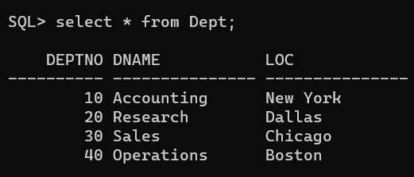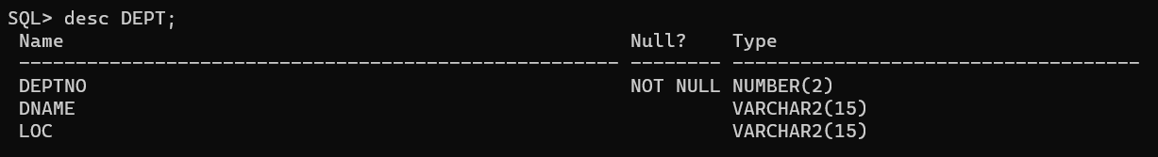

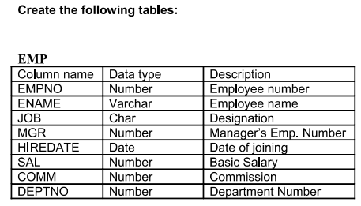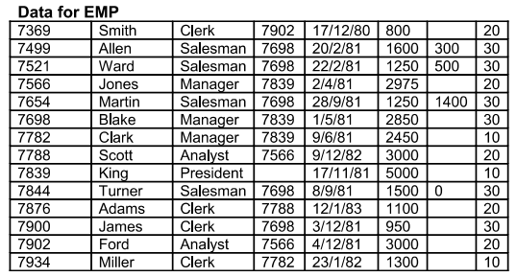



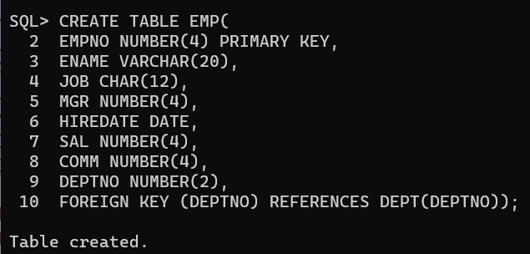

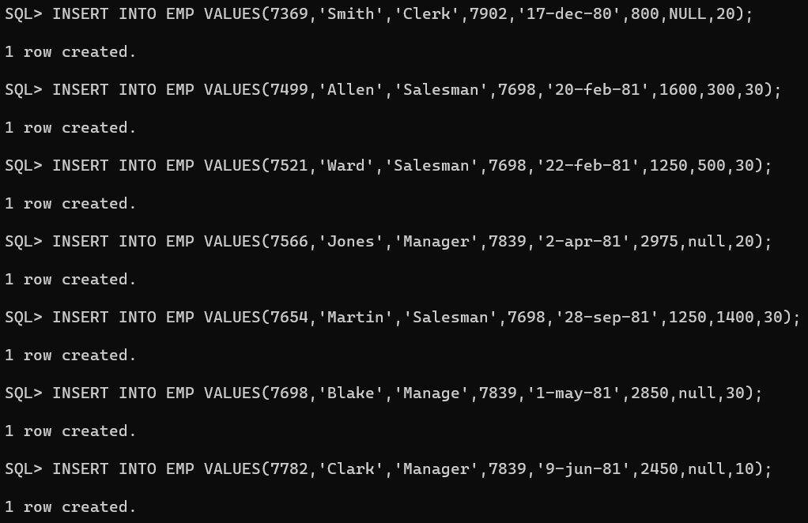 

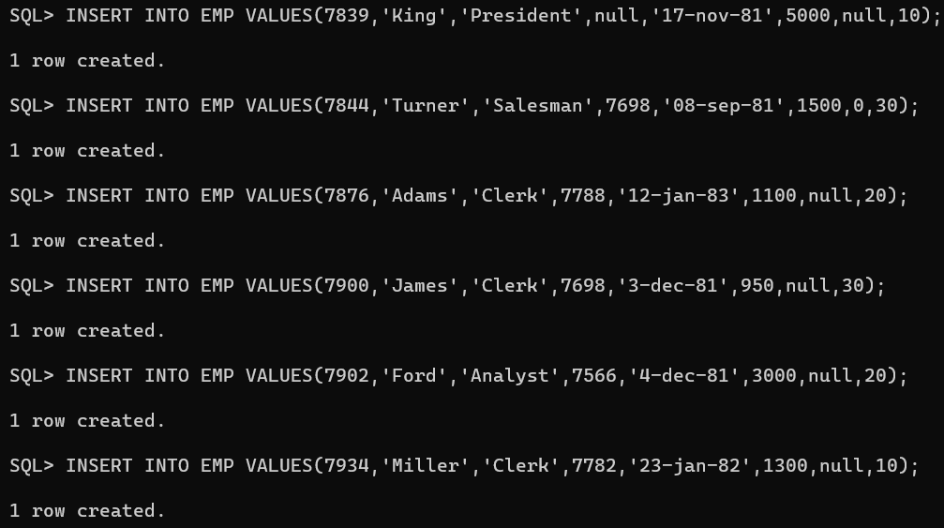

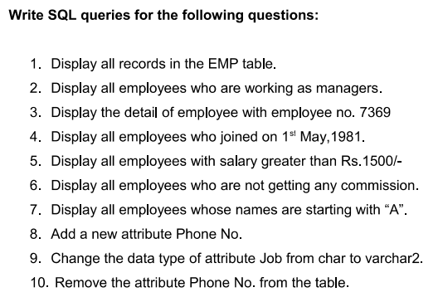

1. Display all records in the EMP table. 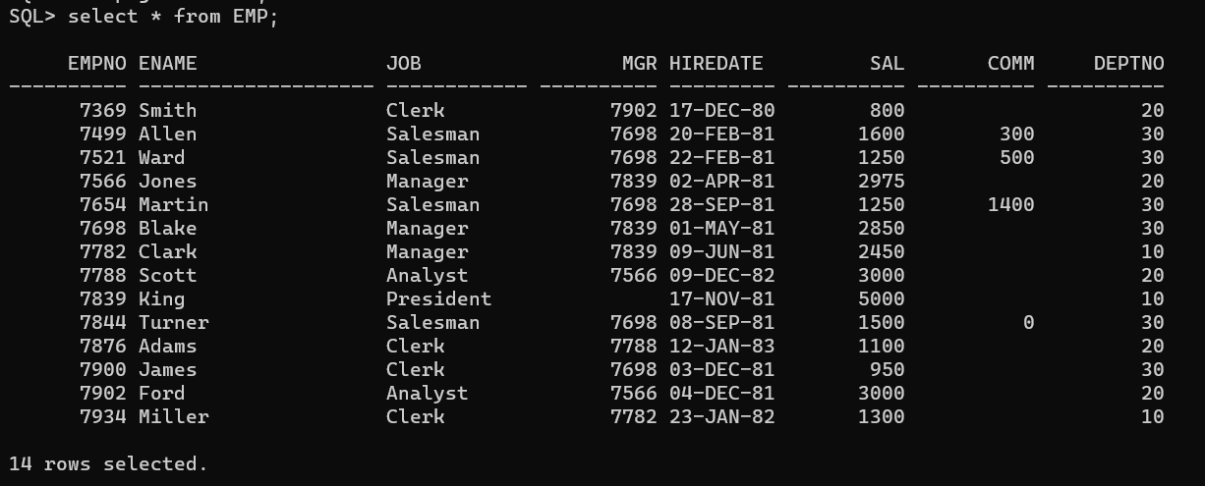

2. Display all employees who are working as managers. 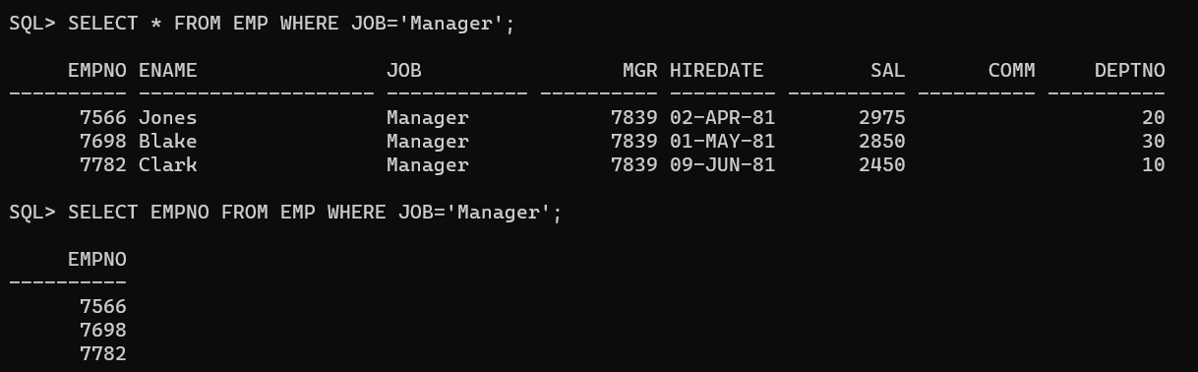

3. Display the detail of employee with employee no. 7369 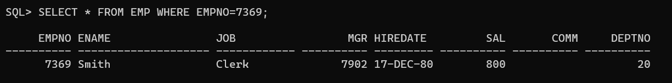

4. Display all employees who joined on 1st May,1981. 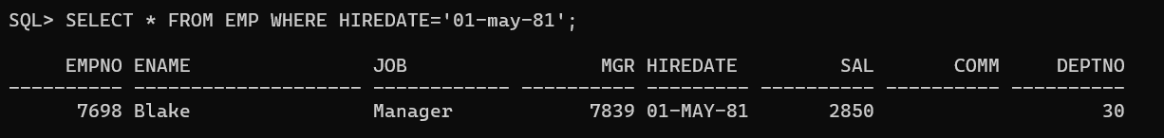

5. Display all employees with salary greater than Rs.1500/-

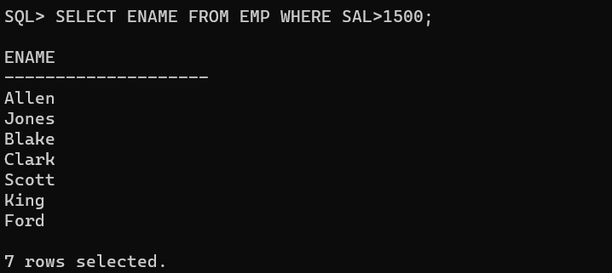

6. Display all employees who are not getting any commission.

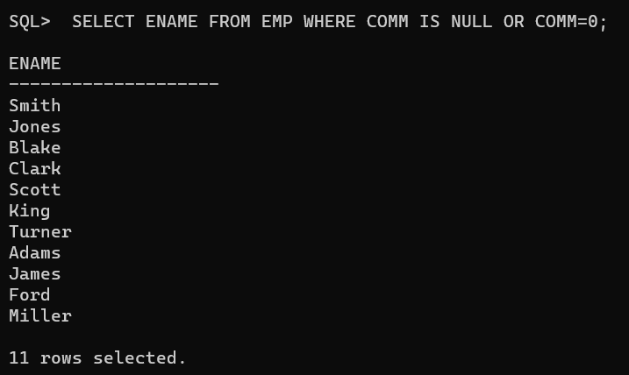

7. Display all employees whose names are starting with “A”.

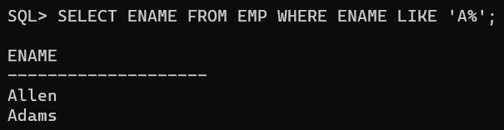

8. Add a new attribute Phone No.

Incorrect ways

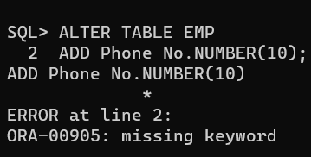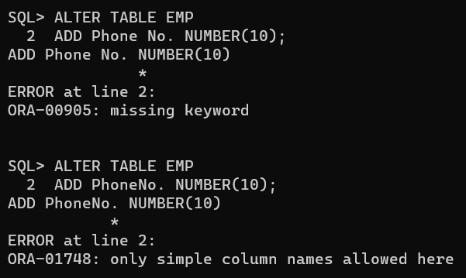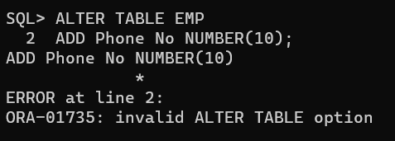

Correct way

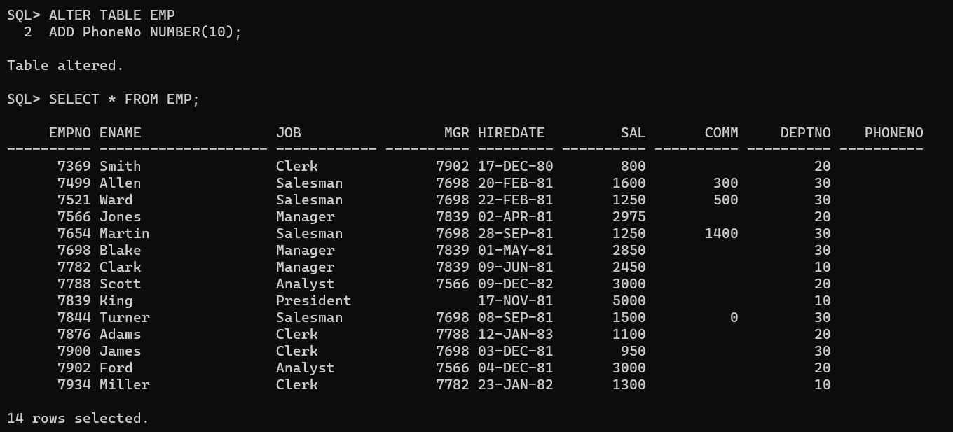

9. Change the data type of attribute Job from char to varchar2.

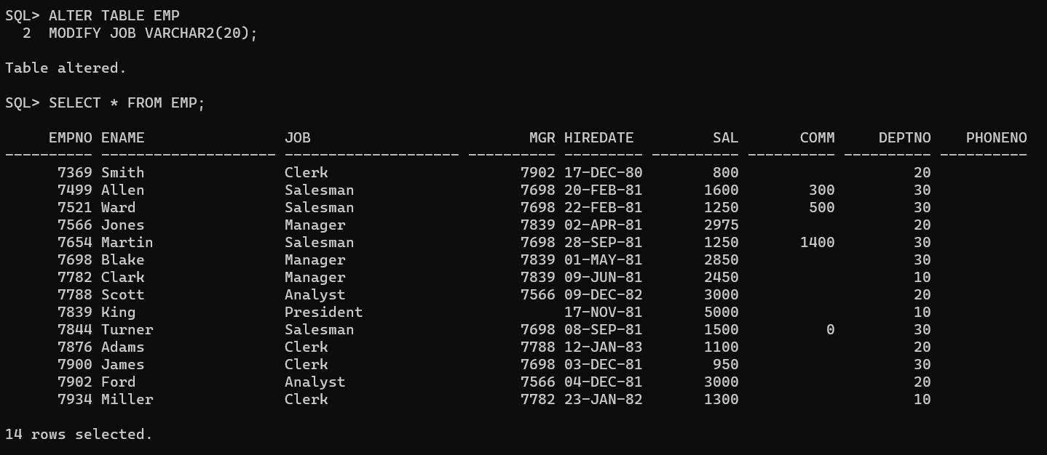

10. Remove the attribute Phone No. from the table

